FOMC Statements EDA
Words used in FOMC per Year
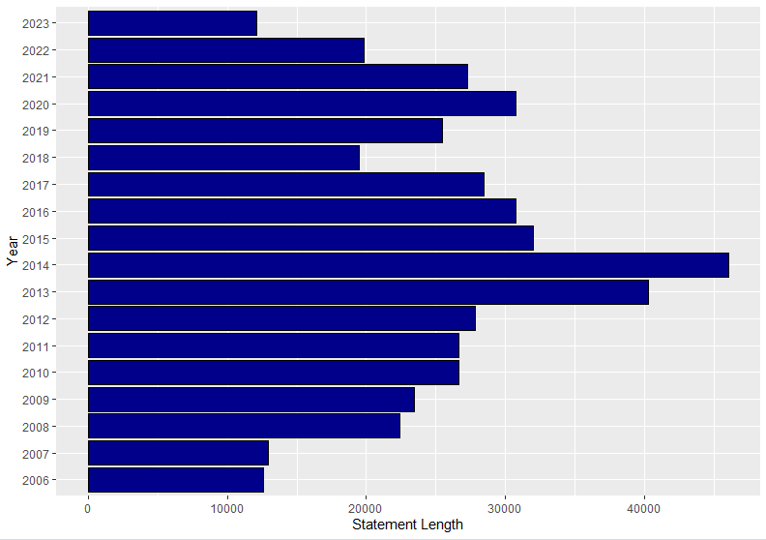
Figure 1.Yearwise word frequency [Rcode1.r]
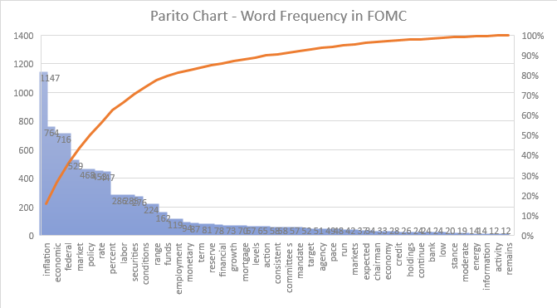
Figure 2. Word Frequency Parito chart [Excel '2.EDA’]
Highest statement length in 2014 and since it is 9th month in 2023 the count is 12127.
Frequency of the word “inflation” in FOMC statements
In 2020, March, three times statement was released and 2020 Sep, inflation frequeny is high, following that till 2021, Jan, frequency count was same.

Figure 3. Year-wise frequency of word ‘Inflation’ [Excel '2.EDA’]

Figure 4. Frequency of the word ‘Inflation’ [Excel:'2.Stme-wise inflation']
a 2006 to 2009 b. 2010 to 2013

Figure 4. Frequency of the word ‘Inflation’ [Excel:'2.Stme-wise inflation']
c. 2014 to 2016 b. 2017 to 2019

Figure 4. Frequency of the word ‘Inflation’ [Excel:'2.Stme-wise inflation']
e. 2020 to 2023

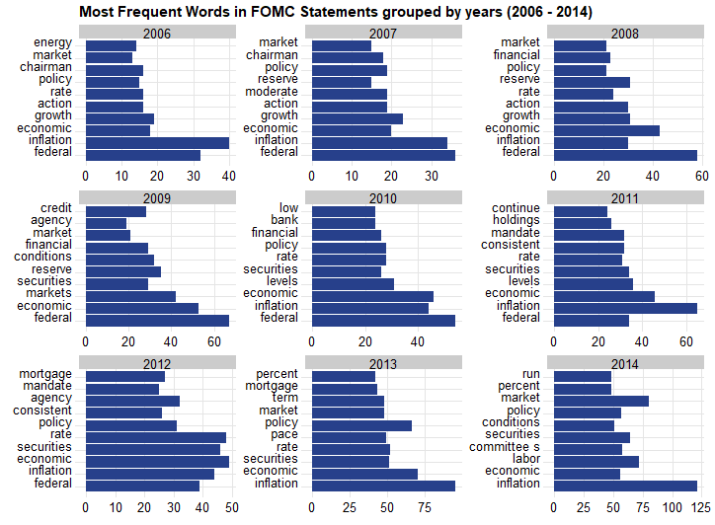
Figure 5.a Year-wise Most frequent word of FOMC (2006-2014) [Rcode1]
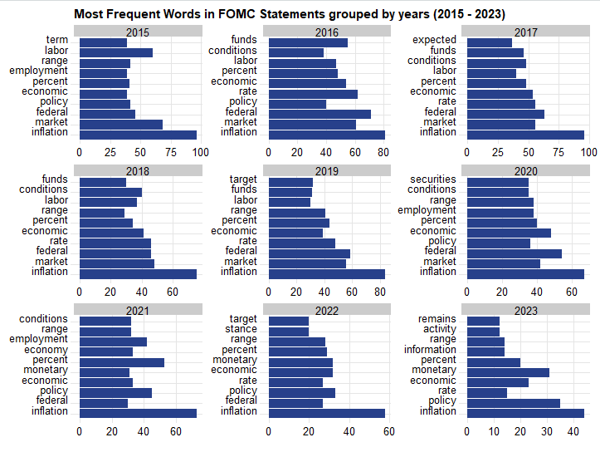
Figure 5.b Year-wise Most frequent word of FOMC (2015-2023) [Rcode1]

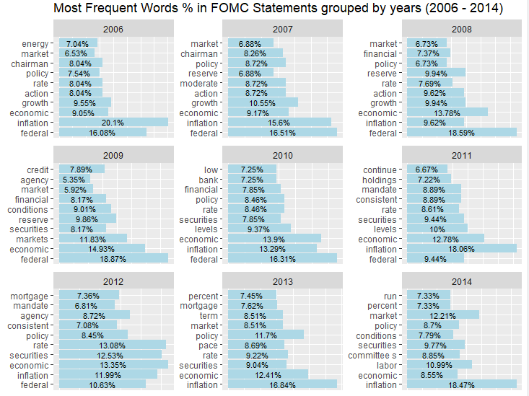
Figure 6.a Year-wise Most frequent words in percentage (2006 to 2014) [Rcode1 using 2.Words_Percent]

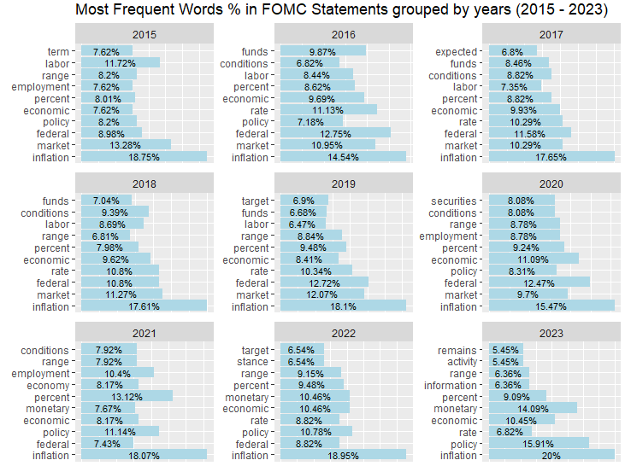

Figure 6.b Year-wise Most frequent words in percentage (2015 to 2023) [Rcode1 using 2.Words_Percent]

Classification Data :EDA

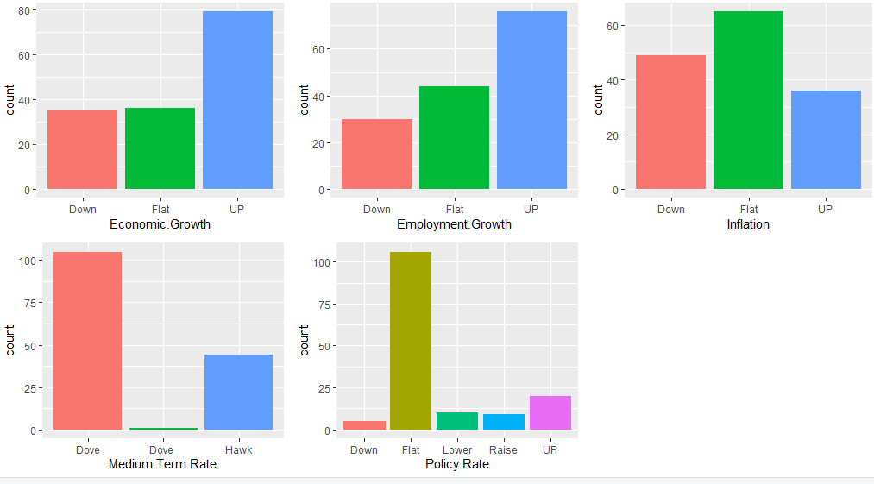

Figure 7. Classification based on Features of FOMC [Rcode1]

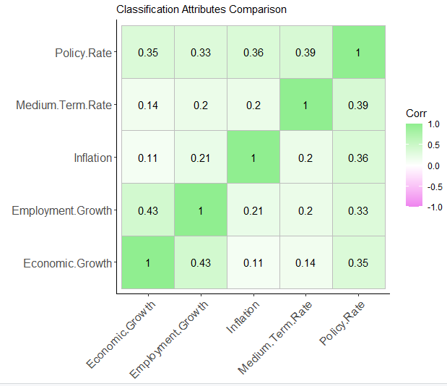
Figure 8. Correlation of FOMC feature [Rcode1]

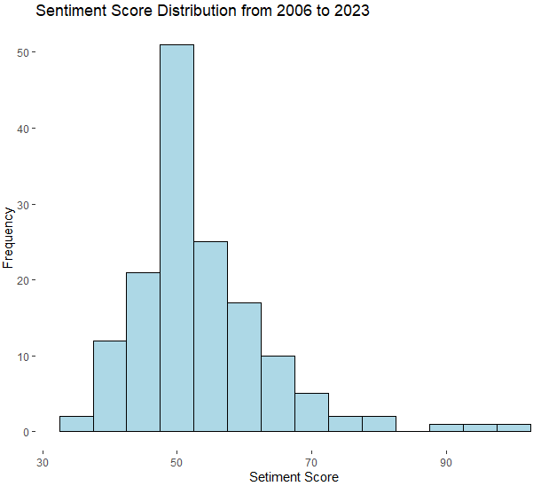
Figure 9. Distribution of Sentiment Score [using ‘1.FOMC_tone.csv’ in Rcode1]

# Line plot to visualize the evolvement of sentiment scores. This is especially helpful when studying a time series of sentiment scores
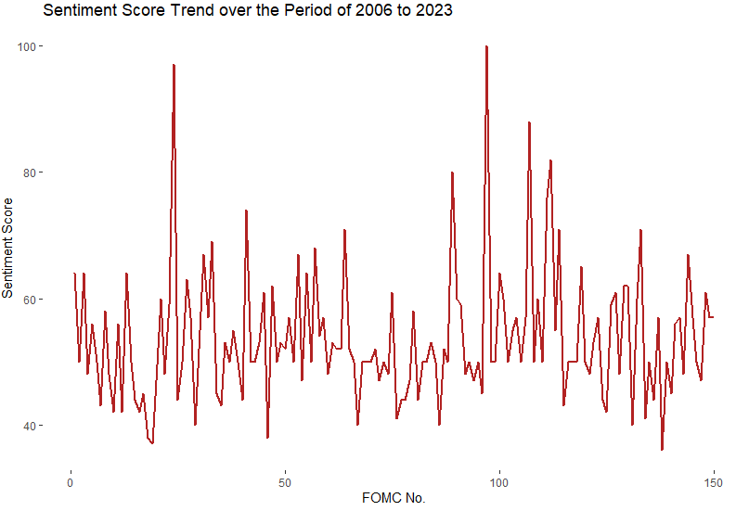
Figure 10. Sentiment weight- Trend [using ‘1.FOMC_tone.csv’ in Rcode1]

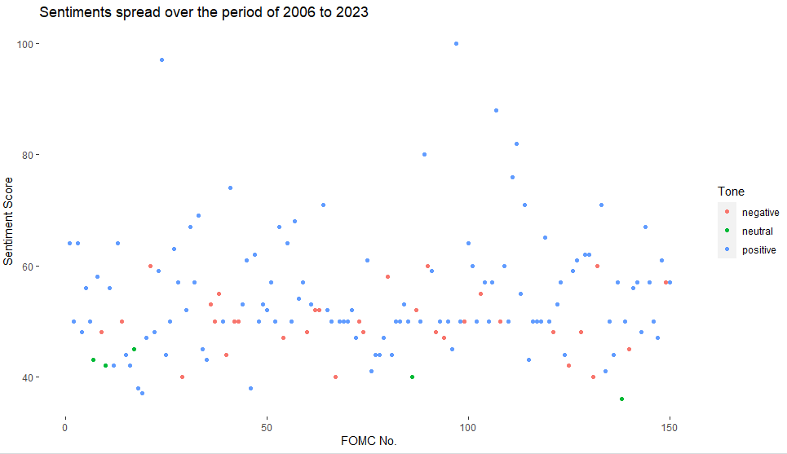
Figure 11. Sentiment each FOMC [using ‘1.FOMC_tone.csv’ in Rcode1]

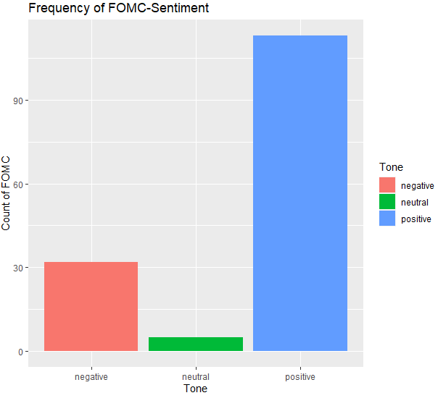
Figure 12 [using ‘1.FOMC_tone.csv’ in Rcode1]

Figure 13 in ‘1.FOMC_tone_EDA.csv’]

Figure 14 in ‘1.FOMC_tone_EDA.csv’]

